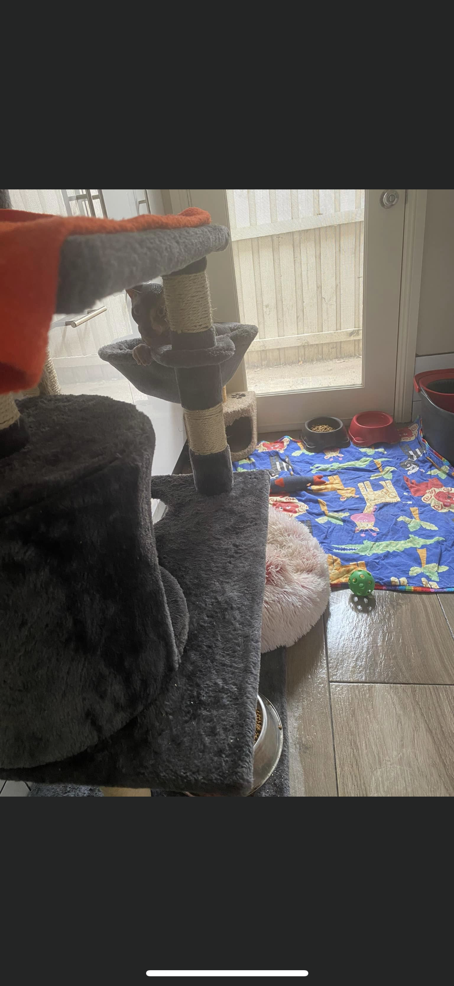  We have three large private rooms with windows, inside our home used for boarding and in home behavior training.  Has Furrvelvet Sphynx Been Awarded Cattery of Excellence….?  YES. In 2019 & in 2022 by ANCATS (The Australian National Cats Inc.)
  Sphynx Boarding
  Boarding is $30 a day and includes:
  *Private room accommodation for stress reduction, with window and feliway calming pheromone diffuser if required.
  *Ozpet litter & tray. Royal Canin sensible biscuits or mother & baby biscuits
  *Bowls, scratching post, blankets and toys are available here in their room
  *If your cat wishes to go for runs or plays around the house, this will be offered twice daily and lots of love given
  # Please bring your own wet food. If on different biscuits please supply and bed/toys or anything that will make the stay more like home. We worm or give medication if required during the stay.
  Contact Us
  Phone: 0407953277
  Email: furrvelvetsphynx@gmail.com
  Web: furrvelvetsphynx.com.au
  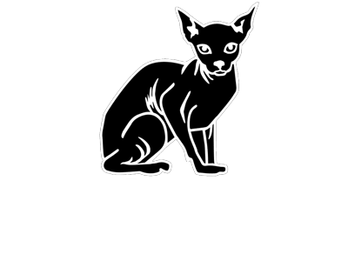 | FURRVELVET SPHYNX!  Camden Park  2570 NSW  AUSTRALIA
  BOARDING & BEHAVIOUR TRAINING
  FURRVELVET SPHYNX!
    - WE NOW OFFER SPHYNX ONLY BOARDING INSIDE OUR HOME FOR WHEN YOUR AWAY AND BEHAVIOUR TRAINING !
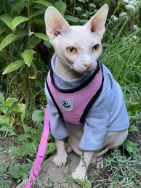  Lead and harness training is a lovely activity to do with your sphynx!  Sphynx behavior training is offered in your home or during boarding. Starting costs at $50 per half hour……  Sphynx owners know they have a unique personality & with that comes a unique understanding of their needs. We provide free phone enquiries for boarding or behavioral training for the life of your baby & offer additional help at a cost if required. This allows us to set up an environment or training program to suit your unique sphynx baby. | Qualifications we hold….  - Certified ANCATs Sphynx Breeder  - Qualification in Domestic Cat Care  - Qualification in Cat Psychology and Training  - I spent 16yrs as a Registered Nurse before I started Sphynx breeding in 2017  Classical conditioning is a technique used to teach cats to learn or become conditioned to a particular sound (eg clicker), smell, or behavior associated with the desired response. We use positive reinforcement with treats, play and affection for the desired outcome. For example, shaking of a lead and harness, means it’s time for our walk. Conditioning can take a few days to a few months to achieve.  Training offered but not limited to…..  - Lead and harness training  - Crate training  - Grooming training  - House training  - Pram training (we have a cat pram so we can try your cat with it prior to you purchasing one) | 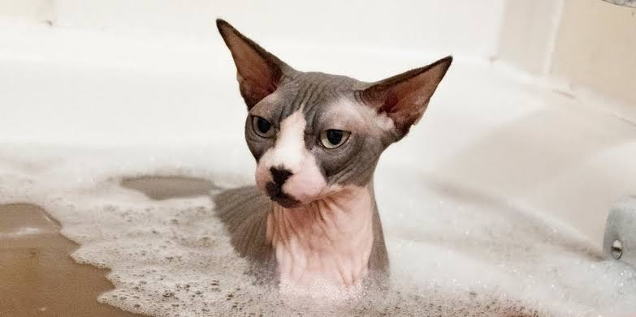  Grooming needs are not liked by all sphynx. We condition them to bathing, ear cleaning, nail trimming ect.  The training principle’s to remember…  - Never hit your cat or get angry  - Ignore negative behavior  - Reward positive behavior only  - Every cat is unique  - It’s easier when your cat is calm  Sphynx training includes ….…  - Daily progress updates with photos during boarding  - Phone support post training  What is best you supply for sphynx training ….…  - The equipment you wish your cat to get conditioned to  - Your cats favorite treats  - A list of anything I should know about your cat, likes or dislikes  - A history of the behavior, when it started and why you think it did

